IAM TASKS
=================================================

- Create one IAM user and assign EC2 and S3 full access roles

steps for Creating IAM User with EC2 & S3 Full Access in AWS IAM
Step 1 — Go to IAM Service
- Logged in to AWS Management Console
- From AWS Services, opened IAM (Identity and Access Management)
- Click Users from the left-side menu

Step 2 — Create a New User
- Clicked Create user
- Gave User name → IAMUSER-1
- Click Next

Step 3 — Set Permissions
- Chose the option: Attach policies directly
- Searched for policy EC2
  - Selected AmazonEC2FullAccess
- Searched for policy S3
  - Selected AmazonS3FullAccess
- Click Next

Step 4 — Review and Create
- Verified the selected permissions:
  - AmazonEC2FullAccess
  - AmazonS3FullAccess
- Click Create user

Step 5 — User Successfully Created
- Message appeared: User created successfully
- On the user detail page:
  - Confirm Permissions tab
  - Verified 2 attached policies:
    - AmazonEC2FullAccess
    - AmazonS3FullAccess

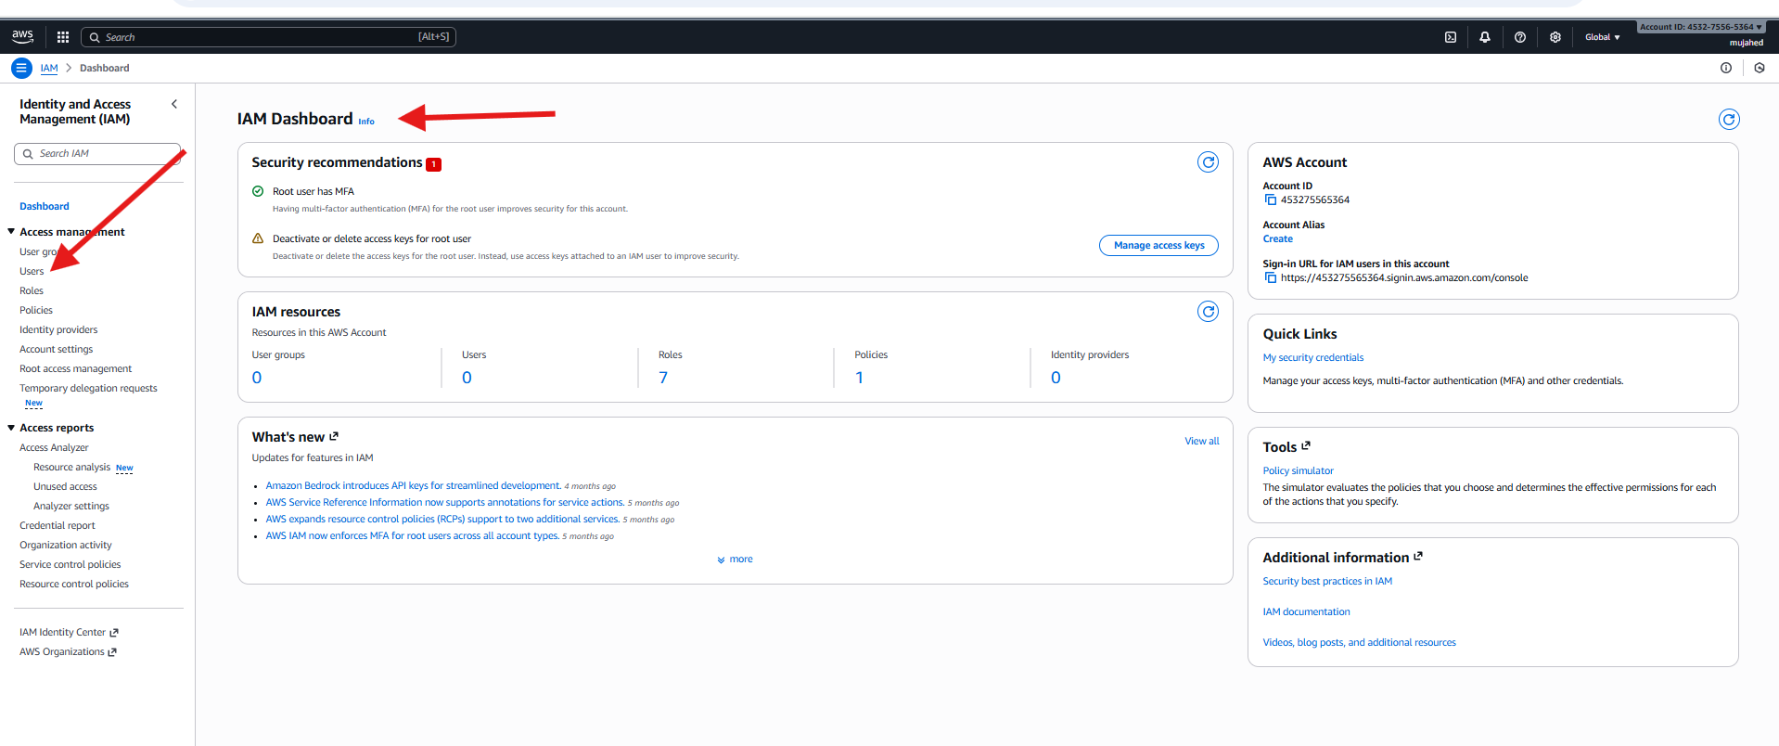

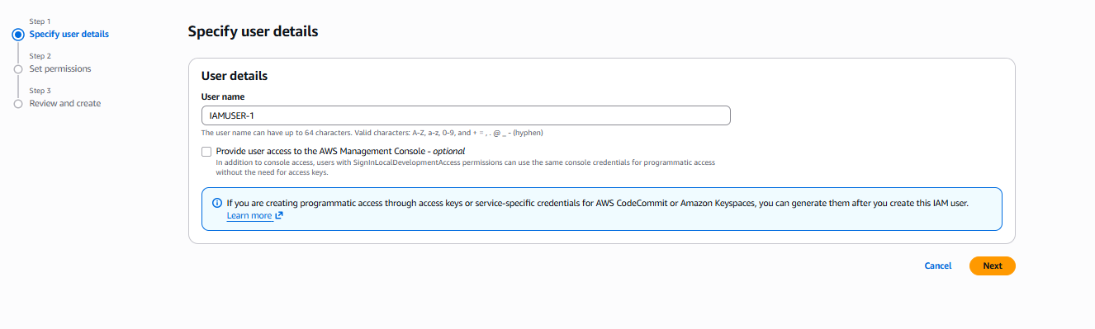

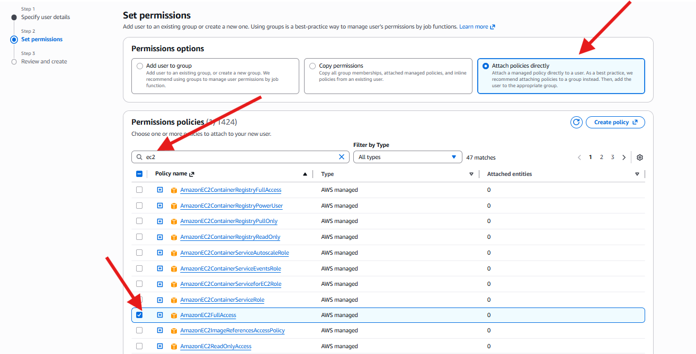

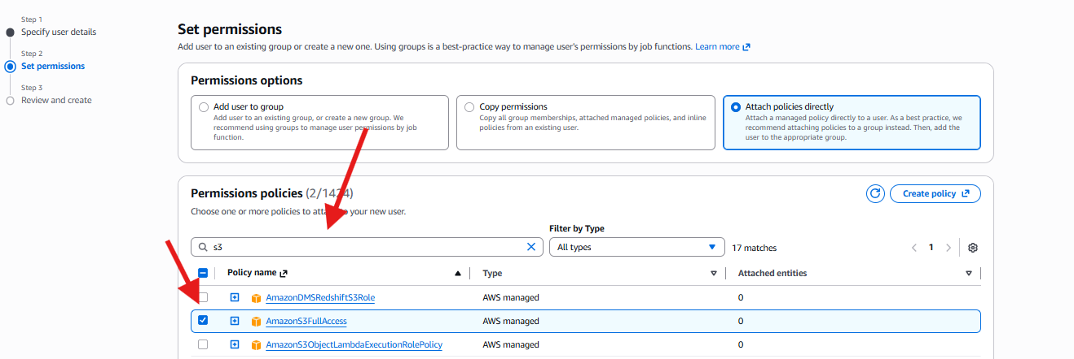

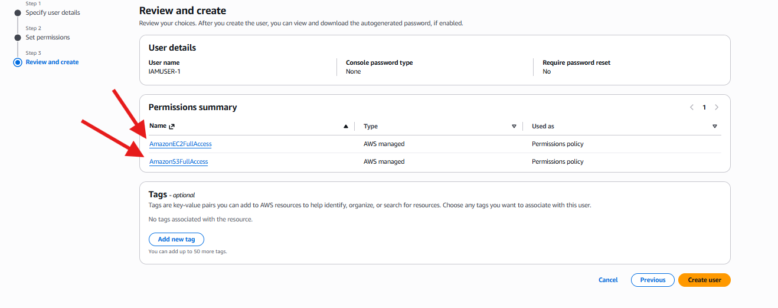

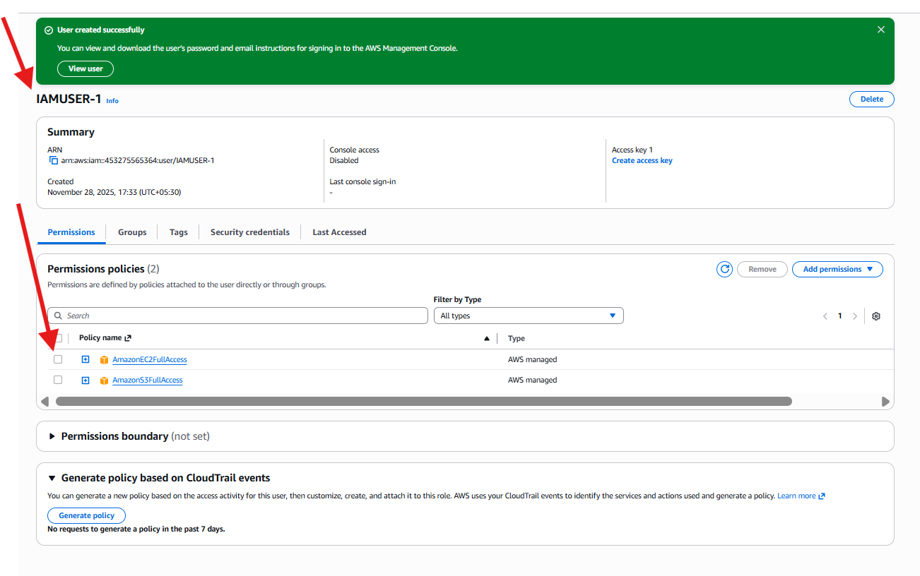

- Create one group in IAM and assign read access for EC2.

Step 1 — Go to IAM User Groups
- Open AWS Management Console
- Go to IAM (Identity and Access Management)
- From left-side menu → Click User groups
- Click Create group (top-right corner)
Step 2 — Configure Group Details
- Enter Group name → IAM-GROUP-1
- Under Add users to the group
  - Select the user: IAMUSER-1
- Under Attach permissions policy
  - Searched EC2
  - Selected: AmazonEC2ReadOnlyAccess
- Click Create group

Step 3 — Group Created Successfully
- A success message appears
- Open group details → Tabs show:
  - Users → Shows IAMUSER-1 added
  - Permissions → Shows:
    - AmazonEC2ReadOnlyAccess (AWS managed policy)

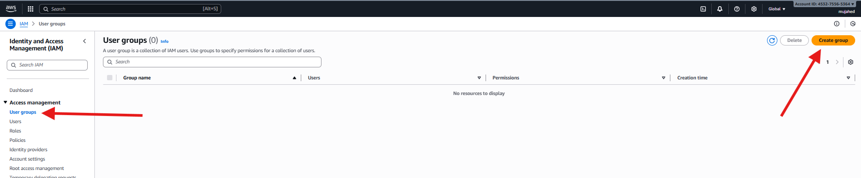

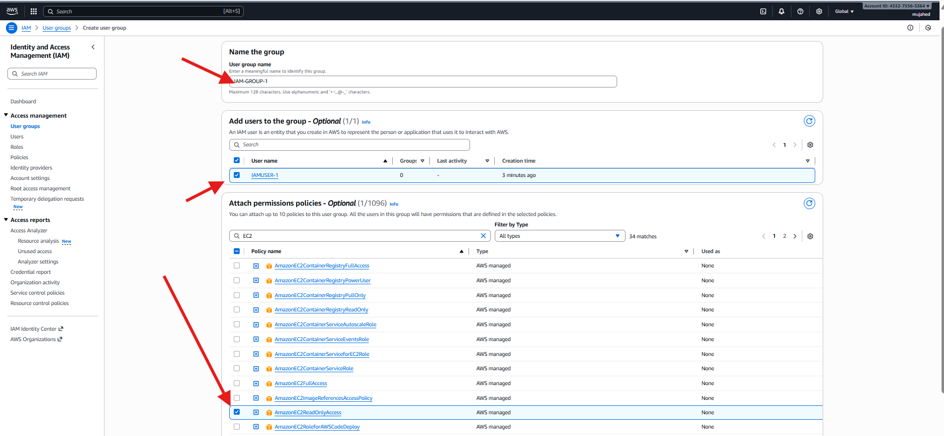

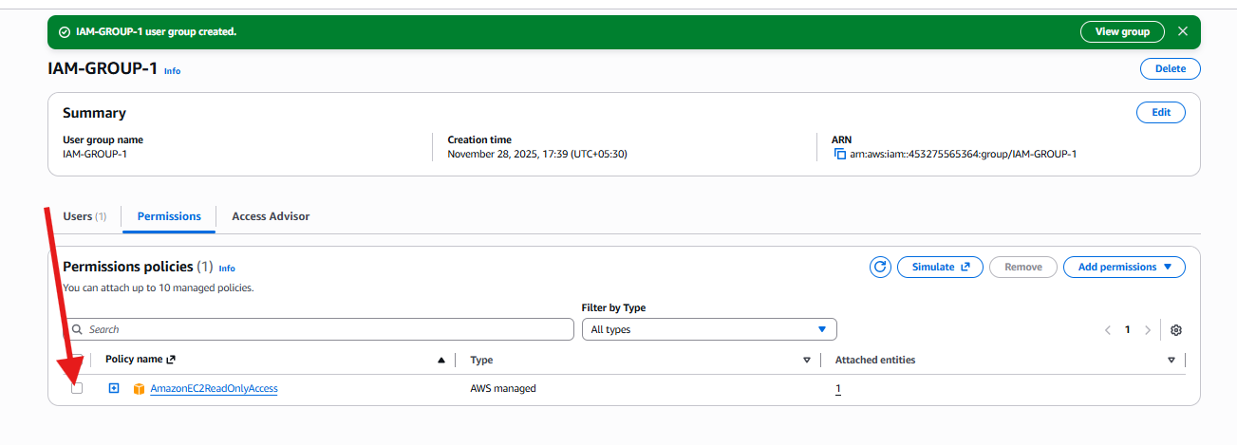

- Create a new user named "Devops" and add to the group created in task 2.

Step 1 — Create IAM User
- Go to IAM service in AWS Console
- Click Users → Create user
- Enter User name → Devops
- Leave console access unchecked (programmatic access only for now)
- Click Next

Step 2 — Set Permissions
- Choose option → Add user to group
- Select the existing group: IAM-GROUP-1
  - (This group already has AmazonEC2ReadOnlyAccess permission)
- Click Next

Step 3 — Review and Create
- Review the details:
  - Username: Devops
  - Permissions from group: IAM-GROUP-1
- Click Create user

Step 4 — Verify User Added to Group
- Go to User Groups → IAM-GROUP-1
- Under Users tab you will see:
  - Devops (new user)
  - IAMUSER-1 (existing user)

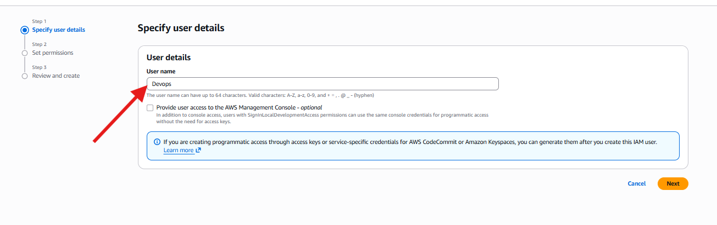

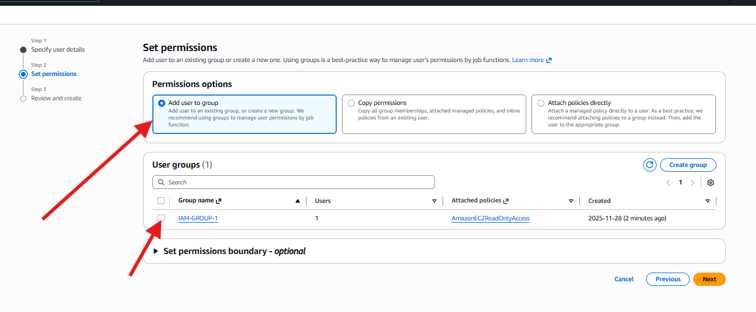

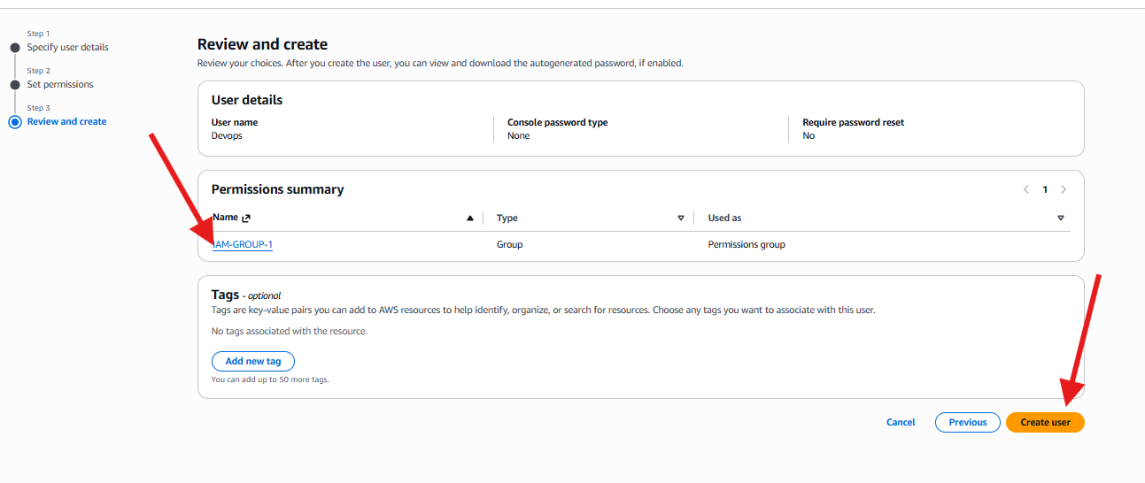

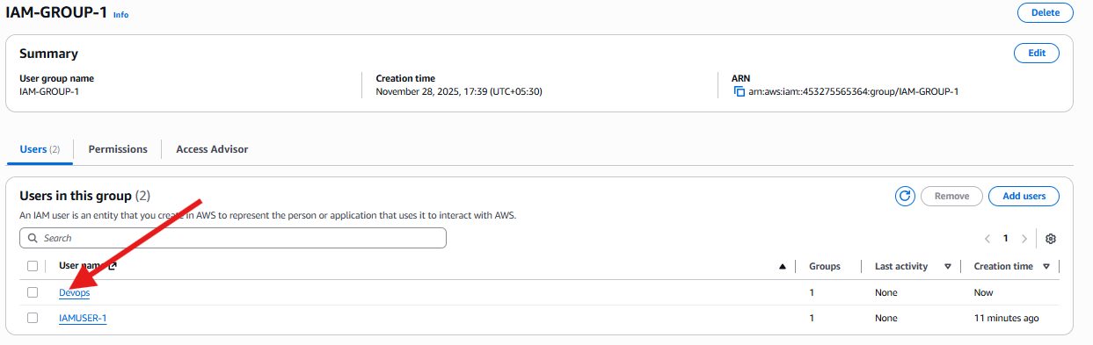

- Write a bash script to create an IAM user with VPC full access

Step 1 — Download & Install AWS CLI
- Went to AWS CLI installation page
- Clicked the MSI download link for Windows 64-bit
(To install AWS CLI version 2)

Step 2 — Verify Installation
In Command Prompt / Git Bash:
aws --version
Output showed AWS CLI installed successfully
Step 3 — Configure AWS CLI Credentials
Command used:
aws configure
Entered:
- AWS Access Key ID
- AWS Secret Access Key
- Default region name
- Default output format = json
CLI is now connected to AWS account
Step 4 — Create a Script to Automate IAM User Creation
Opened file in editor:
vi vpc-user.bash
Script content includes:
- Creating IAM user
- Attaching AmazonVPCFullAccess policy
- Creating Access Key
- Printing success message
Then gave execute permission:
chmod 755 vpc-user.bash
Step 5 — Execute the Script
./vpc-user.bash
Output shows:
- IAM user techie created
- VPC Full Access policy attached
- Access key generated
Step 6 — Verify User in AWS Console
- Opened IAM → Users
- Observed new user techie successfully added
- Status shows active Access Key

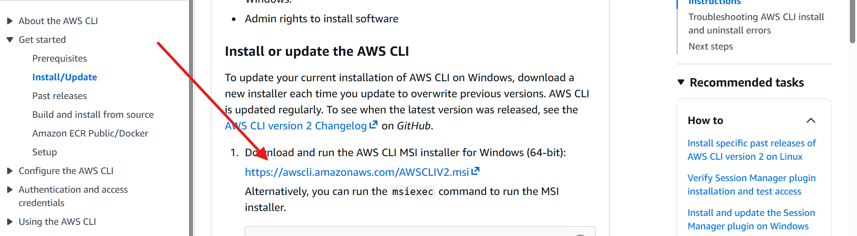

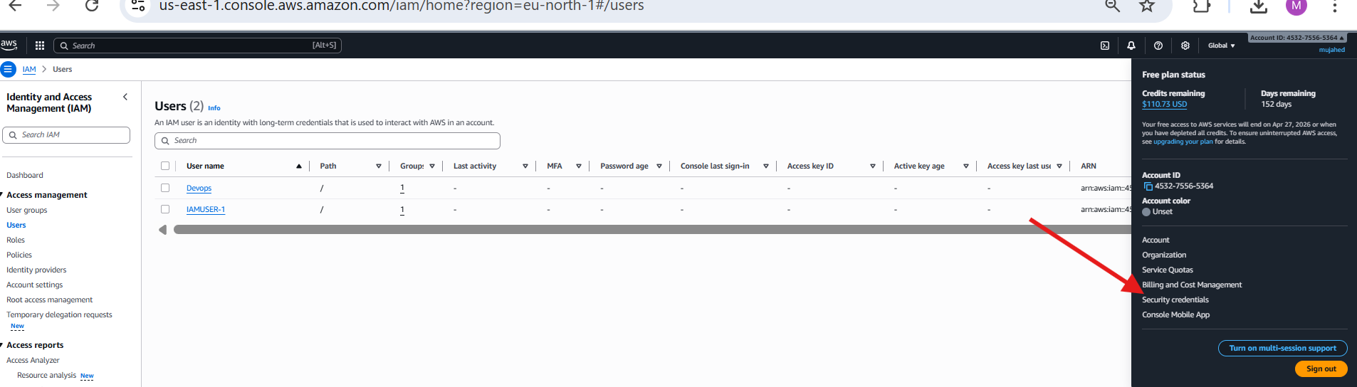

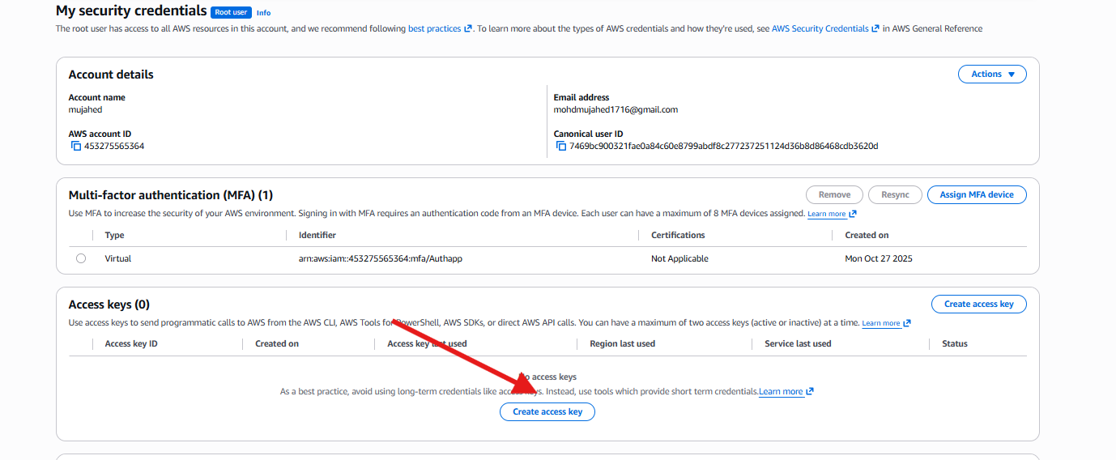

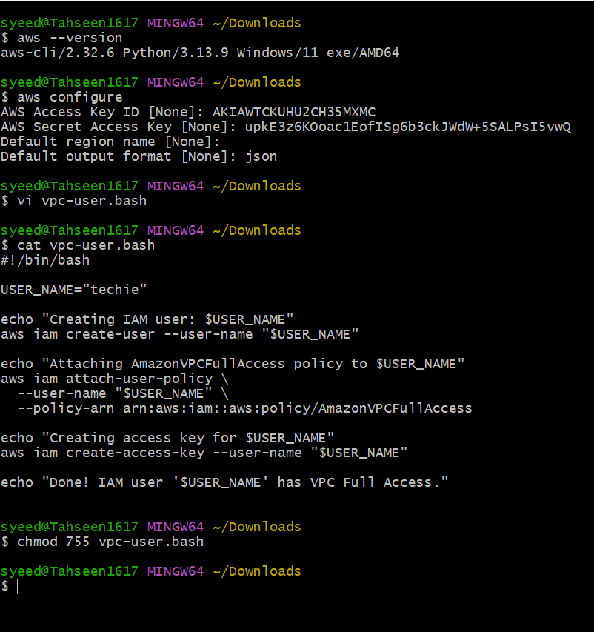

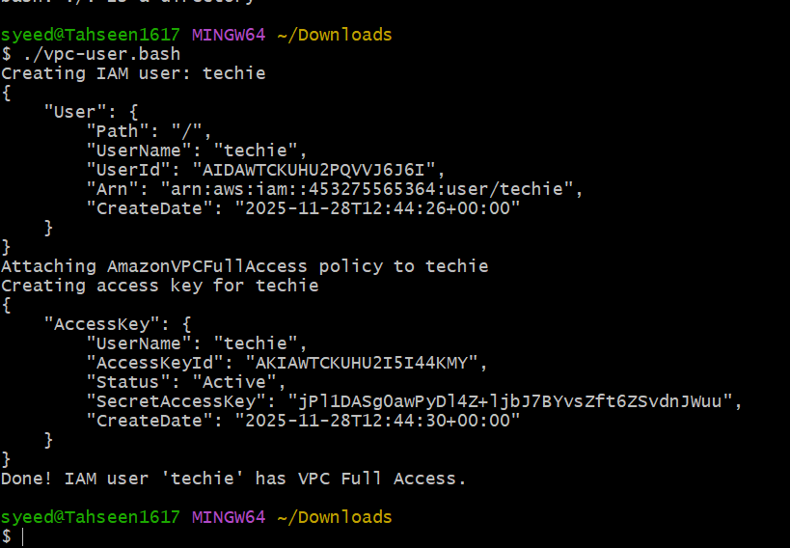

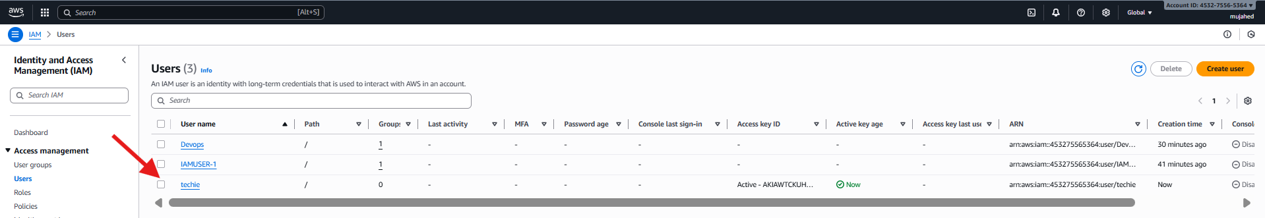

- Create an IAM policy to allow EC2 access for a specific user in specific regions only.

Step 1 — Open IAM Policies
- Go to IAM service in AWS Console
- From left navigation, click Policies
- Click Create policy button (top-right)

Step 2 — Add JSON Policy
- Choose the JSON tab
- Paste custom policy JSON that allows EC2 access only in specific region:
- Click Next

Step 3 — Policy Review
- Enter policy details:
  - Name → policy-ec2-specificuser-specificregion
  - Description → Creating a policy to allow EC2 access for a specific user and specific region
- Click Create policy
Custom policy has been successfully created

Step 4 — Go to IAM Users
- In left menu, select Users
- Click user Devops
Step 5 — Attach Policy to User
- Select Permissions tab
- Click Add permissions
- Choose Attach policies directly
- Search policy → policy-ec2-specificuser-specificregion
- Select the checkbox
- Click Next → Add permissions

Step 6 — Verify Policy Applied
- Under permissions summary
- You will see:
  - AmazonEC2ReadOnlyAccess (from group)
  - policy-ec2-specificuser-specificregion (customer managed)
Policy successfully attached to Devops user
Region-restricted EC2 access granted

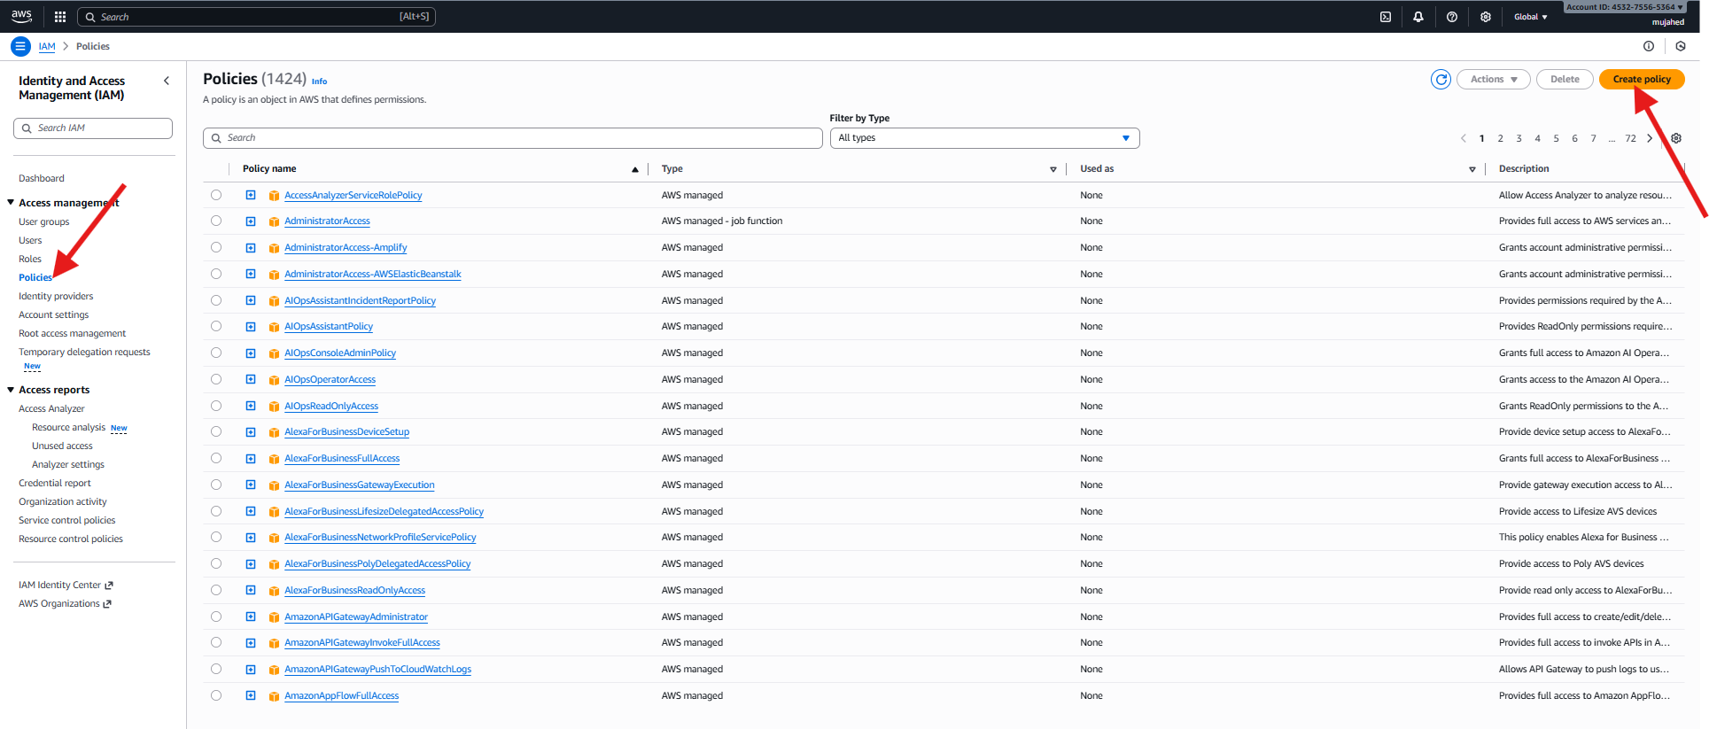

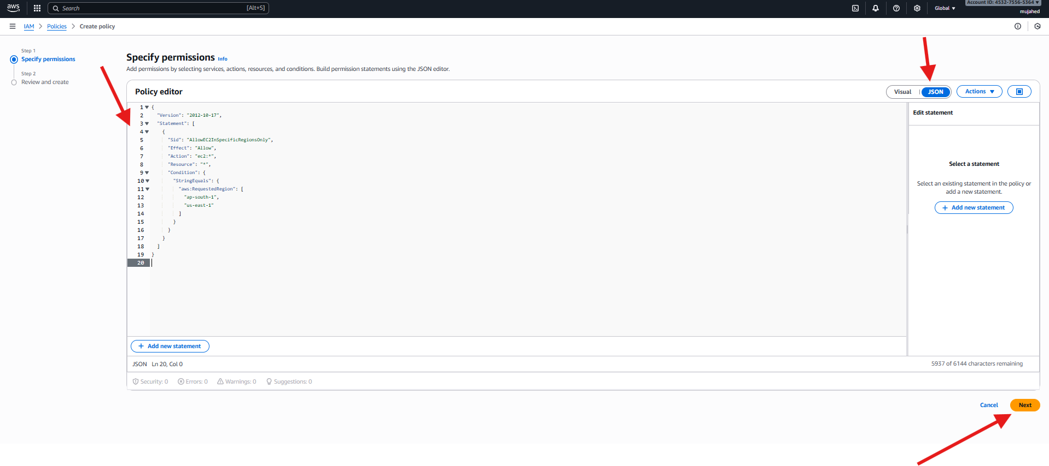

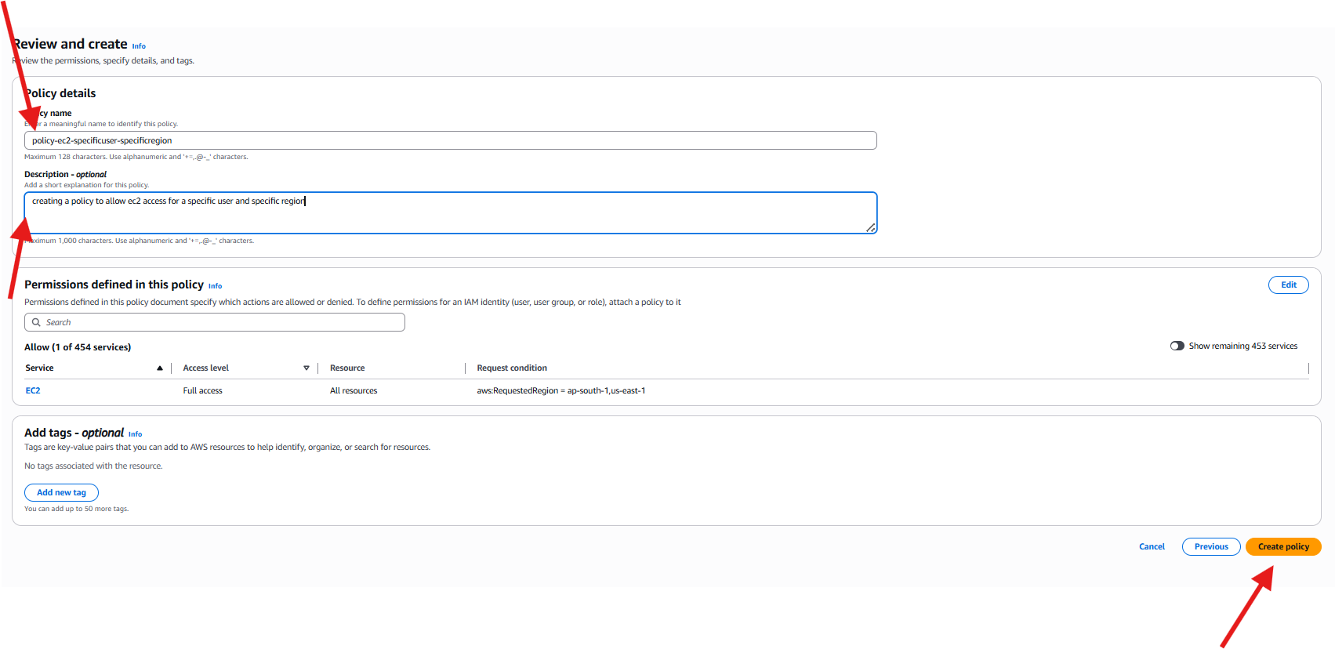

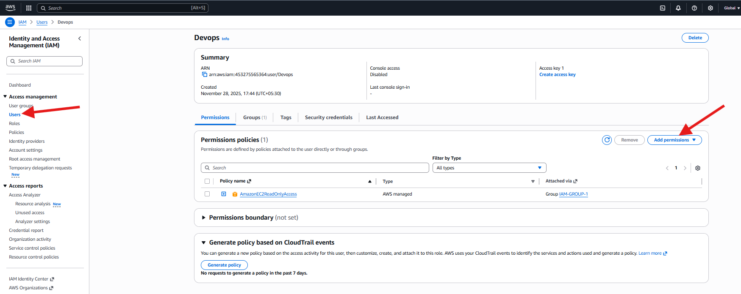

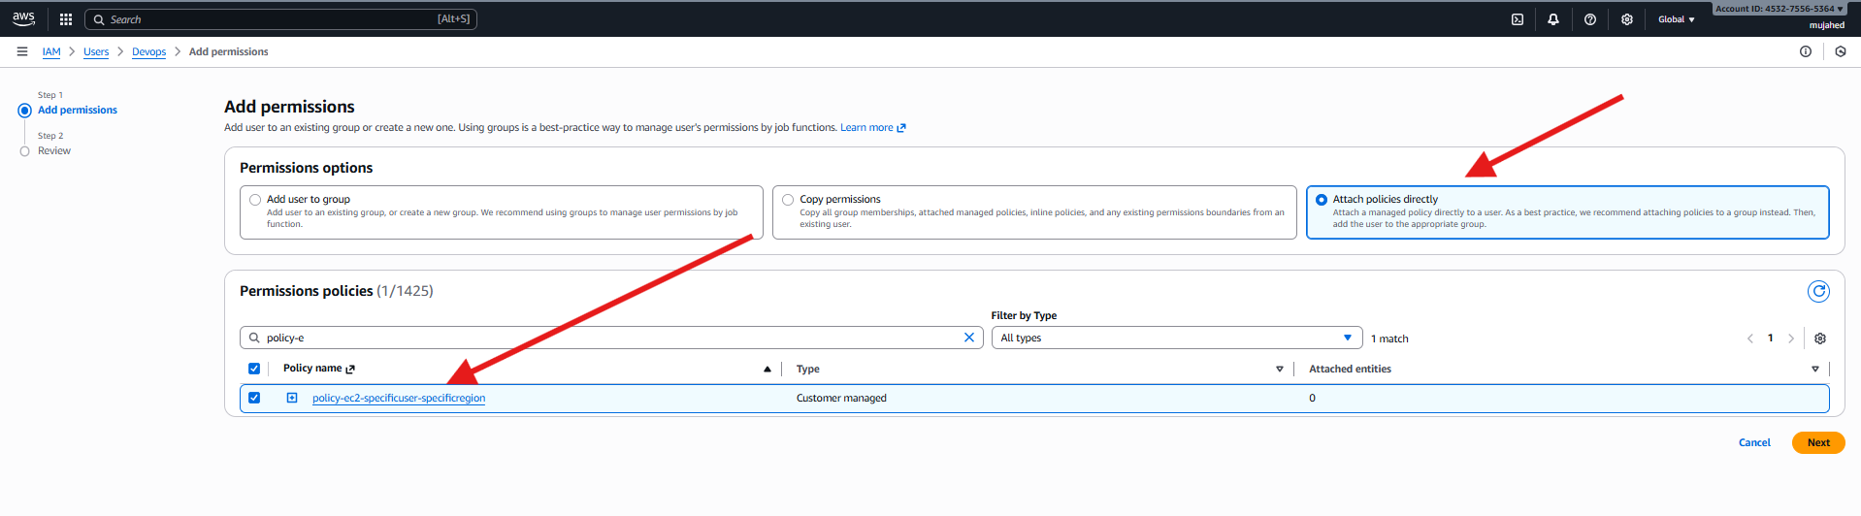

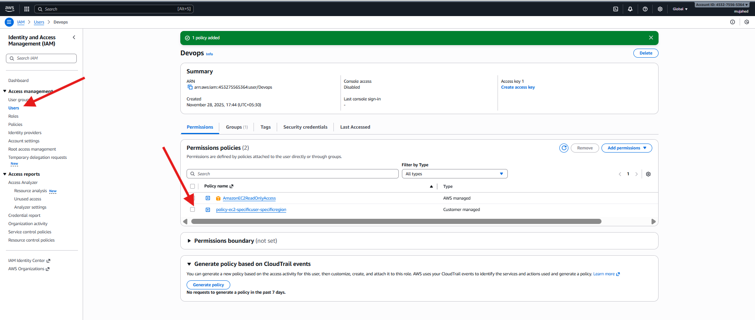

- We have two accounts: Account A and Account B. Account A user should access an S3 bucket in Account B.
(Collaborate with a team member and execute this. This is mostly asked in every interview)

